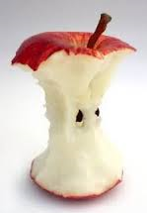Compost

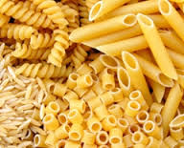

****Recycling

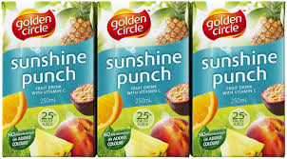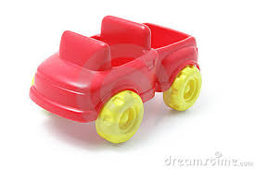

[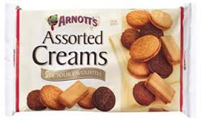](https://www.google.com.au/imgres?imgurl=http://www.schoolandoffice.com.au/images/full/AY150116.jpg&imgrefurl=http://www.schoolandoffice.com.au/products/arnotts-assorted-cream-biscuits-500gm.asp&docid=grcGTrUkfPhMJM&tbnid=G3T3kTHe8-Ev2M:&w=350&h=210&hl=en&safe=strict&bih=805&biw=1440&ved=0ahUKEwj77d-MhoPOAhXKpJQKHRX-DwQQMwhUKDEwMQ&iact=mrc&uact=8)[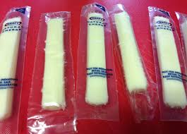](https://www.google.com.au/imgres?imgurl=https://misschriscreations.files.wordpress.com/2013/06/img_3759-2.jpg&imgrefurl=https://misschriscreations.com/2013/06/12/skinny-mozzarella-cheese-sticks/&docid=CQF4KhVTMkZXPM&tbnid=A9JB9dvKoE84oM:&w=3264&h=2351&safe=strict&bih=930&biw=1280&ved=0ahUKEwjjgpjV_e7MAhXGn5QKHZTPCco4ZBAzCCIoHzAf&iact=mrc&uact=8)Soft Plastics

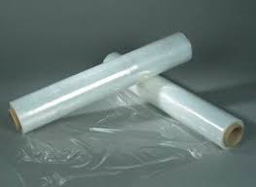

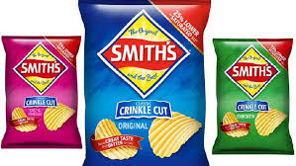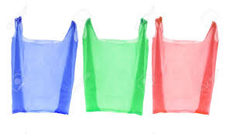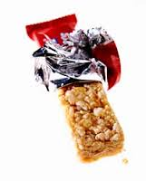Waste



**DAILY**

**Compost**

